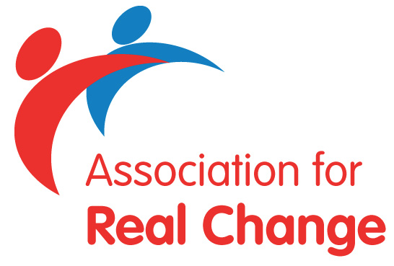
The ARC Disclosure Service

Employer’s Registration Form
– Disclosure Scotland
(PLEASE PRINT THROUGHOUT)

Name: …………………………………………………………………………….......

Title/Role: …………………………………………………………………………….

Name of Organisation: ………………………………………………………………

Address: ……………………………………………………………………………..

……………………………………. Post Code: ……………………………………

Tel No:…………………… Email address: ………………………………………..

When completed please return to the ARC Disclosure Service, via email to: disclosureservice@arcuk.org.uk
Or by post to:
ARC Disclosure Service, 10A Marsden Street, Chesterfield, Derbyshire S40 1JY

All organisations who wish to access the ARC Disclosure Service will need to confirm the following requirements along with copy documentation as indicated below:-

Please note, Disclosure Scotland Code of Practice and sample policies can be found on our website –
https://arcuk.org.uk/trainingservices/disclosure-scotland-guidance-documentation/

 | Requirement | Yes | No
1 | When advertising for job vacancies which require PVG Scheme Membership, this is made known in all job advertisements, applications and recruitment literature
2 | A written policy on the recruitment of ex-offenders, is available to applicants on request and is included in job application packs
3 | All job advertisements, job applications and recruitment literature will include a statement advising job applicants that a criminal record will not necessarily be a bar to obtaining a position and that information it may contain will not be used unfairly
4 | A written security policy concerning the handling and safe-keeping of information is in place and is made available to all job applicants by way of …………………………………………
5 | We have read and will comply with the Disclosure Scotland Code of Practice and job applicants are made aware of this in all our job advertisements, job applications and recruitment literature and a copy is made available to them on request
6 | The Disclosure Scotland Privacy Statement is available to job applicants in our recruitment material and job application forms
7 | The job applicant’s original disclosure certificate will only be kept for a timescale that has been agreed with the applicant and held in line with the Data Protection Act 2018, in order to make a recruitment decision
8 | A signed copy of the Retention Proforma has been provided to the ARC Disclosure Service along with this form

Signed: ………………………………………. Date: …………………………………..
(Handwritten signature, typed names not accepted)

Print Name: ………………………………………………………………………………

Invoicing

ARC will invoice your organisation at the end of each month for any checks carried out on your behalf.

Invoice address – if different from above

Name of organisation: …………………………………………………………………….

Contact: ………………………………………………………………………………………….

Address: ……………………………………………………………………………………………………………………….

……………………………………………………………………Post code:.………………………………………………
Telephone: …………………………………………. Email:……………………………………………………………

Workforce

Please confirm the workforce that your organisation carries out ‘regulated activity’ with:

- Children (under 18 years of age) ☐
- Vulnerable Adults (age 18+) ☐
- Both Vulnerable Adults and Children ☐

Primary Contact and ID Checker Details

Name of Primary Contact: …………………………………………………………

Email: ……………………………………………………………………………………….

PLEASE NOTE: IT IS THE PRIMARY CONTACT’S RESPONSIBILITY TO INFORM ARC OF ANY CHANGES WITH REGARDS TO THEIR ID CHECKERS TO COMPLETE PVG APPLICATIONS LISTED BELOW, i.e change of name, no longer undertaking the role of ID checker, left organisation etc.

The following person/s has/have been nominated by this organisation as ID checkers to complete the PVG application form:

Name: …………………………………………………………………………………………….

Email: ………………………………………………………………………………………………

Name: ……………………………………………………………………………………………….

Email: ………………………………………………………………………………………………

Name: ………………………………………………………………………………………………

Email: ………………………………………………………………………………………………

ARC Disclosure Service will provide important quarterly updates and useful information to the Primary Contact for their review, action and dissemination to other ID checkers within their organisation.

Would you like to receive information on any others services provided by ARC?
- membership

- training

- events

Disclosure Scotland Code of Practice https://arcuk.org.uk/trainingservices/files/2015/11/Disclosure-Scotland-CodeofPractice_Feb_2011.pdf

ARC Privacy Notice http://arcuk.org.uk/privacy-policy/

ARC takes your privacy seriously and will only use your information to administer the products and services you have requested from us. We will never sell your data and we promise to keep your details safe and secure.

