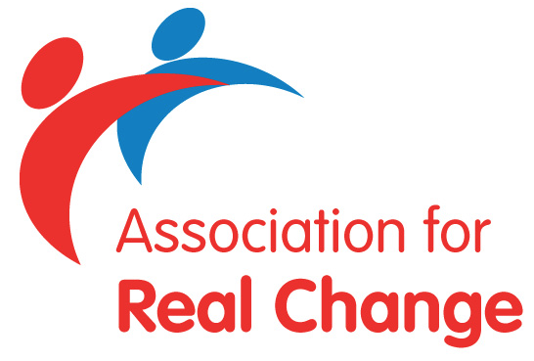

ARC Disclosure Service

Association for Real Change (ARC) Disclosure Service are requiring confirmation that our member organisations handling and retention of Disclosure information is in compliance with Disclosure Scotland’s Code of Practice.

We are therefore requesting all member organisations that use the ARC Disclosure service to sign the pro-forma below.

I, ………………………………………………… , as an appropriately authorised representative

of……………………………………………………………………………….. (Organisation)

confirm that I have read and will adhere to Disclosure Scotland’s current Code of Practice and also confirm that any Disclosure information will be destroyed within 90 days after the date on which the recruitment or other relevant decisions have been taken, or after the date on which any dispute about the accuracy of the Disclosure information has been resolved.

Signed:…………………………………………………………………….
(Handwritten Signature, typed names not accepted)

Position in Organisation:………………………………………………….

Date:………………………………………………………………………

