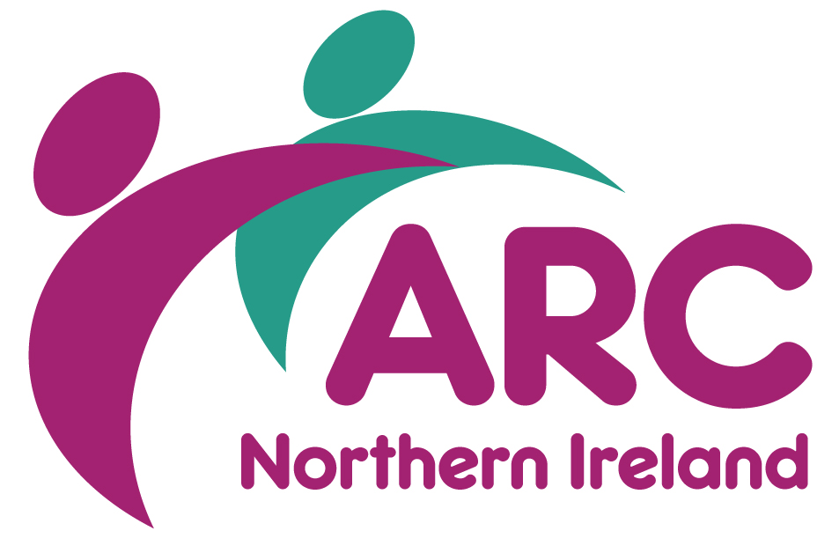
TRAINING BOOKING FORM

Course Title
Course Date
Start Time
Venue

Name
Job Title
Organisation
Address
Town/City |  | Postcode
Email
Telephone
Special Requirements
Dietary, mobility, access etc

Line Manager
Email
☐ I am an ARC member ☐ I am not a member of ARC

PAYMENT
☐ I enclosed a cheque ☐ Please invoice
All invoices will be sent directly to your finance/accounts payable. Please ensure you have obtained a Purchase Order No (PO) from your finance/account payable before submitting form, as it will be returned if not fully completed.

Finance Name
Finance Email
Your PO No

Please return completed booking form to Training Department, ARC (NI), Wildflower Way, Boucher Rd, Belfast BT12 6TA or by email to training.ni@arcuk.org.uk

Cancellation charges will apply. For any queries or additional information please call 028 9038 0960
If you are booking as an ARC NI member, your email address will be automatically added to our distribution list where we will keep you up to date with future training and events. At any time, you can remove yourself from this by either emailing arc.ni@arcuk.org.uk.
If you are not an ARC NI member, and/or this is a personal email address, and you would like to continue to hear of our up and coming training and events, please tick here:
BOOKING ARRANGEMENTS & CANCELLATION CHARGES

Booking arrangements | Places can only be secured by completing the appropriate booking form which is available on request from the Training Department at the ARC (NI) office.  Tel: 028 9038 0960  Email: training.ni@arcuk.org.uk  Place will be allocated on a first come, first serve basis, so early booking is advisable.  Please Note: Booking forms are used for invoicing purposes and it is essential line management authorisation is provided, if required.
Payment | On completion of the course an invoice will be issued and payment can be made with by cheque or BACS payment.
Your cancellation charges | If you are unable to attend the course you are booked on, you may substitute, by prior arrangement and after notifying us, someone else from your organisation.  If you are unable to attend, and cannot or do not wish to give the place to someone else in your organisation, we may accept the fee paid as payment towards a place on the same or another course that takes place within 12 months following the originally booked event.  Such a transfer will be on condition that we are informed in writing of your intentions two weeks prior to the originally booked event. Bookings can only be transferred once.  If you are unable to attend, and not in a position either to transfer your place to another person or to another event, then the following charges will apply:  Cancellation charges - training courses  10 working days before the course: 50%  5 working days before the course: 75%  less than 4 working days before the course: 100%  Please note that full payment is required for non-attendance on a booking that has been transferred.  Free Courses – The charges applied to free courses for cancellation or non-attendance is as follows:  10 working days before the course: no charge  5 working days or less before the course: £30  Non-attendance: £45
ARC’s cancellation | ARC NI events and courses are periodically updated and while we endeavour to deliver the courses as advertised there may inevitably be occasions where we have to change content without prior notice or, in exceptional circumstances, to cancel an event.  In the case of a course cancellation delegates will either be offered an alternative date, a credit note or a full refund and we will also consider any reasonable request to cover non-refundable travel arrangements if a course is cancelled within 2 working days of the start day.
Time unless otherwise stated | All full day courses will run from 10.00am—4.00pm, and a light lunch will be provided.
Venue unless otherwise stated | ARC (NI)  Ash Grove  Wildflower Way  Boucher Road  BELFAST BT12 6TA  Tel: 028 9038 0960
Costs unless otherwise stated | Full Day Session Half Day Session  ARC Member: £85.00 ARC Member: £45.00  Non-Member: £105.00 Non-Member: £60.00

