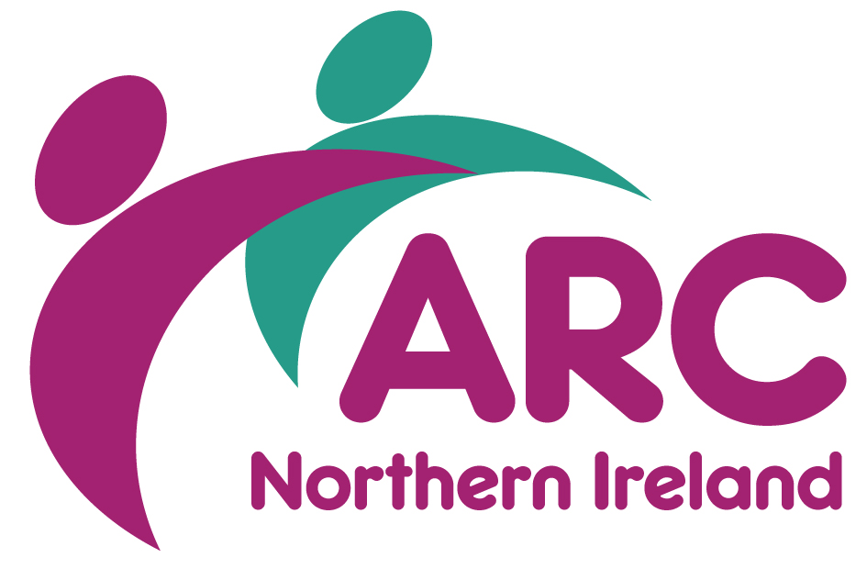
Application for Membership 2020/21

Organisation Name: Click here to enter organisation name
Name of Chief Executive (or equivalent): Click here to enter name of CEO
Head Office Address: Click here to enter address
Click here to enter address.
Click here to enter town/city. Postcode: Click here to enter postcode
Tel: tel number Website: Click here to enter web address.

About Your Organisation
Does your organisation only support people with learning disabilities? Yes ☐ No ☐
What type of organisation are you: Choose an item.
What type of service does your organisation provide? (Please tick all that apply):
Advocacy ☐ Domiciliary Care ☐
Residential Care Living ☐ Supported Living ☐
Daytime Opportunities ☐ Specialist School ☐
College, Training etc ☐ User-led organisation ☐
Other (please specify) Other (please specify

In which Health & Social Care Trust area do you provide services? (Please tick all that apply):
Belfast ☐ Northern ☐
South-Eastern ☐ Southern ☐
Western ☐

Which of following regulatory bodies apply to your organisation, if any?

NISCC ☐
RQIA ☐
Other (please specify) Other (please specify)

How many paid staff does your organisation employ? Paid Staff

How many volunteers does your organisation support? Volunteers

How many people are supported by your organisation’s services? Click here to enter text.

We are extremely keen to represent our Members. Please provide a brief statement about your organisation to be used on the Member’s Page
provide a brief statement about your organisation

Nominated Representative(s)
Membership applies to the whole organisation – from the CEO to frontline staff. Please indicate the name and details of your organisation’s nominated representative for the following areas of work:

NAME | JOB TITLE | EMAIL | PHONE
Senior Managers Think Tank (must be a decision maker within your organisation)
Name | Job Title | Email | Phone Number
RQIA & ARC Executive Exchange (Senior Managers level and above)
Name | Job Title | Email | Phone Number
Workforce Development (can be HR or Practice Based posts)
Name | Job Title | Email | Phone Number

ARC also facilitates two peer networks which are optional and an additional charge of £100 per network is required to cover venue, catering and speakers. Please tick if you are interested in receiving the nomination forms for:

Adult Safeguarding Champions Peer Network ☐
Registered Managers Peer Network ☐

Membership Fees
The membership year runs from April – March, but newly joining organisations pay pro-rata for their annual subscription for the remainder of the year. Membership fees are based on the organisation’s annual turnover. Please tick the appropriate box: | Band | Turnover Level £ | Annual Fee £
 | ☐ A | < £1m | £275
 | ☐ B | £1m - < £10m | £550
 | ☐ C | £10m+ | £825

Commitment Statement
On behalf of my organisation, I hereby apply for membership of the Association for Real Change, Northern Ireland. I authorise ARC to communicate with any relevant and interested staff who work for my organisation. I have read the philosophy of ARC and confirm that I stand fully behind the beliefs it endorses and will strive to put them into practice.

Signed: By printing your name, you are authorising this application Date: Click here to enter a date.

As an ARC NI member, your email address, including the nominated reps will be automatically added to our distribution and workstream lists where we will keep you up to date with future training and events. At any time you can remove yourself from this by emailing arc.ni@arcuk.org.uk.

What Happens Now?
Your application will be considered and invoiced accordingly, following which you will receive a welcome pack via email from the Director.

ARC NI is only as strong as its members so we look forward to welcoming your organisation’s contributions and thank you for your application.

Philosophy – Our Beliefs

Everyone is unique. Everyone can make valuable contributions to society.
The Association for Real Change champions equal human rights for all and defends the right to freedom, respect, protection, equality, and self determination. Everyone should be treated with dignity in their daily lives and all services must promote this principle.

- We believe that everyone should be treated equally and, as unique individuals, everyone makes valuable contributions to society.

- We believe that person centred values and models of support are the best way to improve people’s quality of life.

- We believe that everyone should have the support they need to be included in their local community.

- We believe that people should have the opportunity to be involved in how their support is planned and delivered at both a local and national level.

- We believe that everyone who plans or delivers support should have access to the knowledge, experience and skills they need to continually improve what they do.

- We believe that people’s quality of life can be improved by supporting those who plan and deliver support to work effectively in partnership with each other and with the people they support.

- We believe in the capacity of those who plan and deliver support to continually reflect and change their practice to improve what they do.

- We believe that people are best placed to make informed choices about how they live their lives.

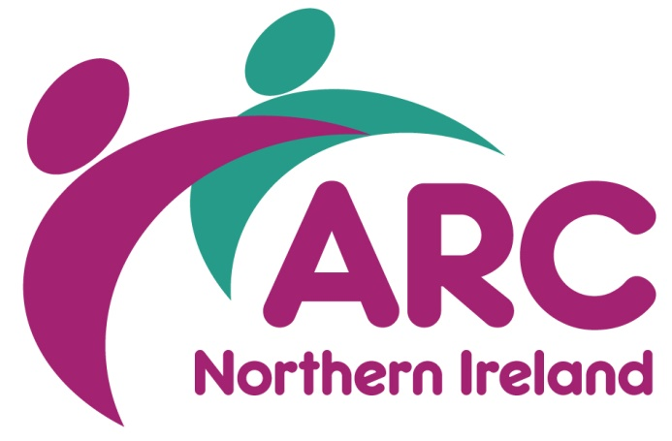
Association for Real Change, Northern Ireland
Wildflower Way, Boucher Road
Belfast, BT12 6TA
 028 9038 0960
 arc.ni@arcuk.org.uk
 arcuk.org.uk/northernireland
@arcni
facebook.com/arcnorthernireland

