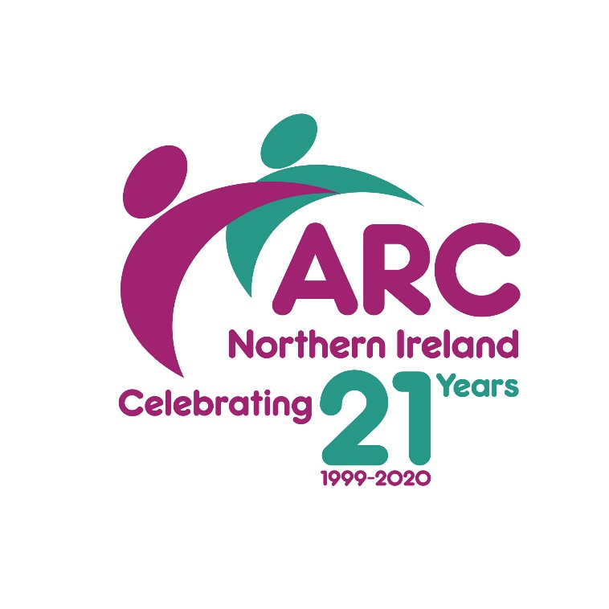

Call for
Workshop Papers

‘THE TIME MACHINE’ CONFERENCE
THURSDAY 11TH & FRIDAY 12TH JUNE 2020
WATERFOOT HOTEL – DERRY/LONDONDERRY

ARC NI invite you to submit a workshop proposal for a conference to be held on Thursday 11th and Friday 12th June 2020. As this conference is part of ARC NI’s 21st Birthday celebration, we wish to celebrate the past; the present; and the future.

The conference theme, ‘The Time Machine’ is based on a science fiction novel, published in 1895 which has three key themes, namely:

- Inequality
- Technology
- Revolution

The conference will be attended by approximately 125 stakeholders within the learning disability sector, including regulators; policy makers; providers; and people supported. The conference aims to:

- highlight the progression achieved in the learning disability sector over the past 21 years
- showcase what current services and or support offer a person with a learning disability
- consider the future needs of people with a learning disability and their families and how we can best support them to lead a meaningful life.

If you are interested in facilitating a workshop, for 1 hour and 20 minutes, you are invited to complete and forward a brief proposal on the form overleaf.

The workshop should:

a) address one of the below topics:
- Services / Support
- Safeguarding
- Citizenship

and

b) state clearly how it will integrate one or more of ‘The Time Machine’ themes within the key messages namely:

- Inequality
- Technology
- Revolution

Please note workshops will run on Day One only and last for 80 minutes.

Each workshop will receive one free day place at the conference.

Workshops should have no more than 3 facilitators.

CLOSING DATE FOR WORKSHOP PROPOSAL: 21 FEBRUARY 2020

To submit a proposal please complete the attached Proposal Form and return to Stephen Walker at stephen.walker@arcuk.org.uk

Informal enquiries are also welcomed by contacting Stephen Walker on 028 9038 0960; or by emailing stephen.walker@arcuk.org.uk

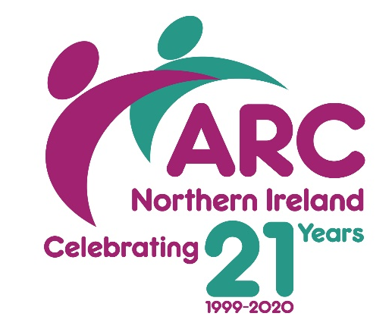
ARC (NI) CONFERENCE 2020

‘The Time Machine’

Workshop Proposal

PLEASE PRINT CLEARLY AND COMPLETE FORM FULLY

Facilitator’s Details
Name
Organisation
Address
Town/City |  | Postcode
Telephone
Email
Workshop Title
Workshop Aims
NAME OF PRESENTER (S)

Brief Description of Workshop
Equipment Needed | Data projector & Screen Flip Chart  DVD player and TV Other (please specify)

Return complete Workshop Proposals Stephen Walker at stephen.walker@arcuk.org.uk

