Telling It Like It Is!

TILII! We are advocacy groups of men and women with a learning disability who work together to develop confidence in speaking out about what matters to us.

Before you join TILII we would like you to know that:
A) You need to be able to travel by yourself either by taxi, bus, train or get your carer to bring you. If you use public transport you need to pay for this yourself
B) Everyone respects each other and works together as part of a team sharing their skills and knowledge.

C) We support you to build your skills and look at your greatest strengths and interests for you to decide the area you would most like to represent TILII in ie. Roving Reporter, Training or Recruitment.

As a TILII member you will learn how to
- Train the Trainer – Share your experience and improve your skills to educate staff on how to support someone with a learning disability.

- Advocacy Training -TILII develop and deliver training to their peers on speaking out to insure their voices are heard
3. Roving Reporter – Learn the right questions to ask people to get good information and present your findings to different audiences.

What we do
- We have minimum two meetings a month - sometimes we meet outside the meetings to do other TILII work.

- We train people on how to support someone with a learning disability.

- We deliver training on how to involve people with a learning disability in choosing and developing the staff who support them.
- We gather evidence and write reports to celebrate what is happening in the learning disability sector.

- We campaign to improve the lives of people with Learning Disabilities.

- We talk about Rights, Respect and other important issues.
- We learn how to speak up for others and ourselves.

- We put people in touch with each other and pass on important information.
- Discuss ideas with other groups to strengthen skills and share examples of good practice.

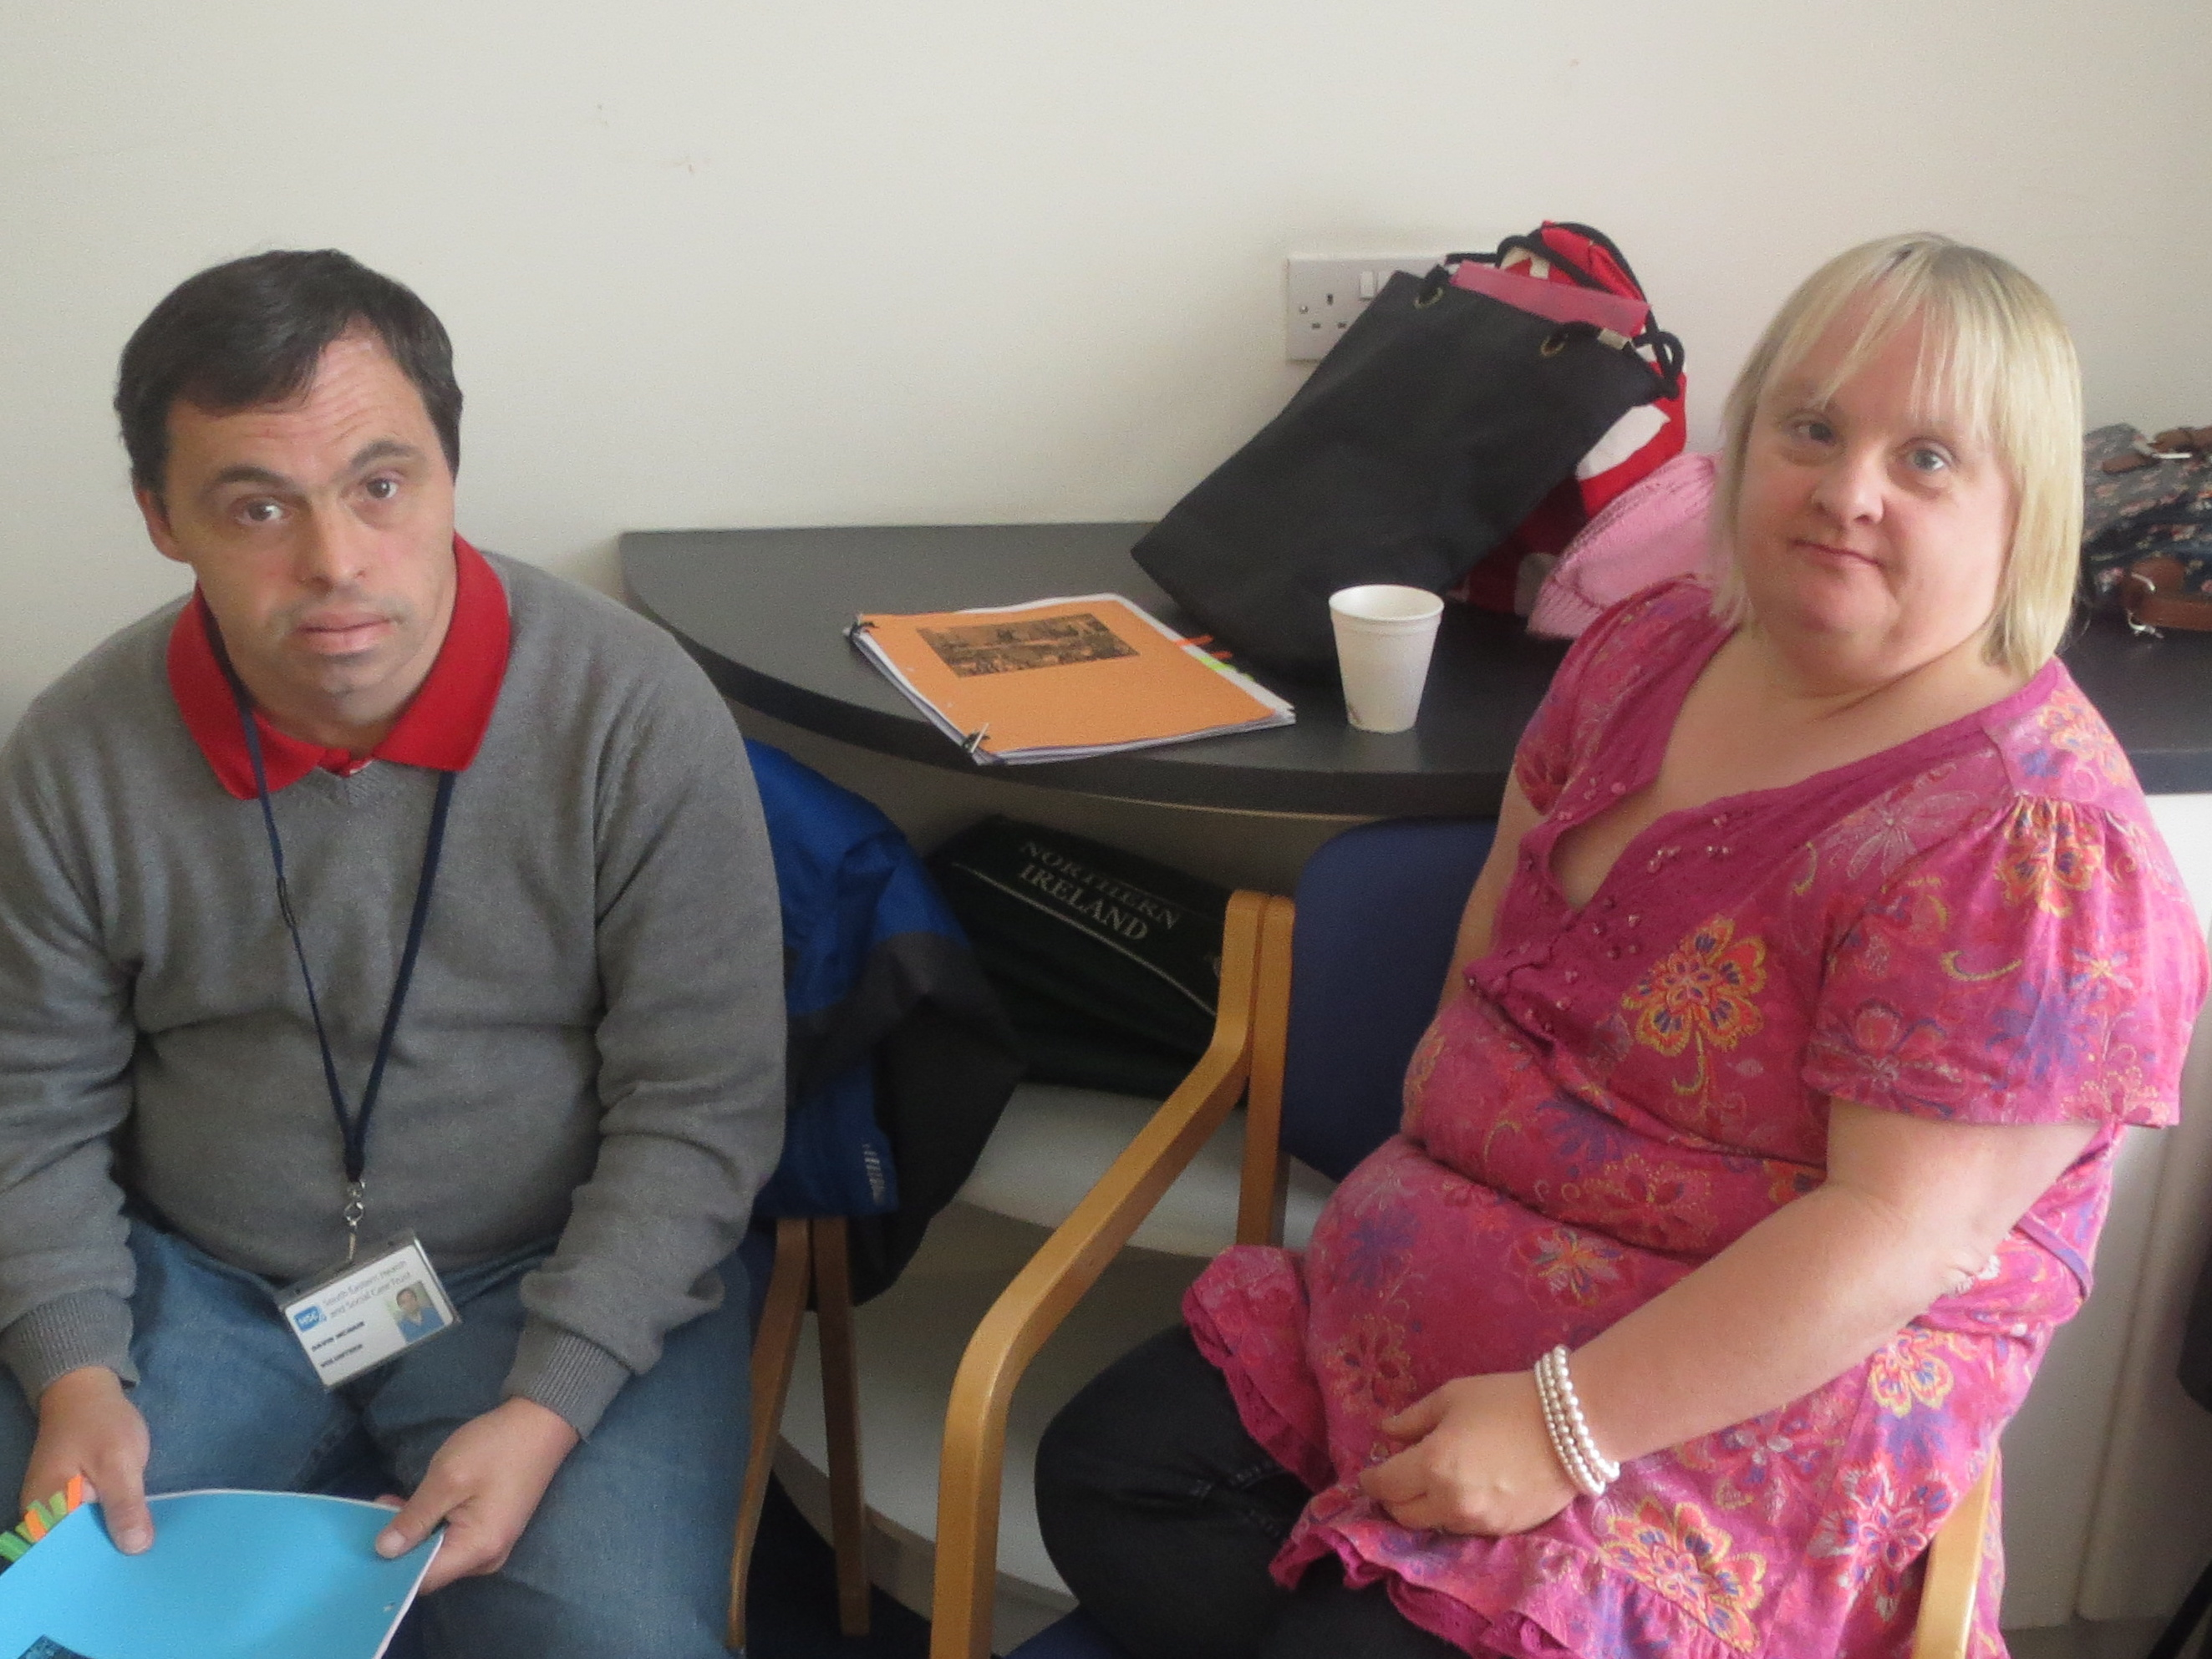
“ I enjoy being part of TILII, I like doing presentations and training staff members, I am good at doing role plays. I like to speak up for myself in the TILII meetings.” David, TILII Bangor

ARC NI are looking for new members – join today!

For an Application form and further information, please contact:
Louise at
02890 380960 or
louise.hughes@arcuk.org.uk

