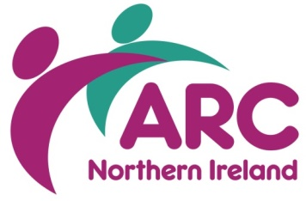
Governance and Accountability
Requirements of Safeguarding Adults
Friday 10 November 2017| 10.00 am – 12.30 pm
Early Years, 6c Wildflower Way, Belfast BT12 6TA
BOOKING FORM

PLEASE PRINT

Organisation
Address
Town/City |  | Postcode
Email
Telephone
Person 1
Role
Person 2
Role
Special Requirements
Dietary, mobility, access etc

Costs per organisation (2 places):
☐I am an ARC member: £40 ☐ I am not a member of ARC: £70
☐I enclosed a cheque ☐ Please invoice me

Please return completed booking form to Stephen Walker, ARC (NI), Wildflower Way, Boucher Rd, Belfast BT12 6TA or email to stephen.walker@arcuk.org.uk

Cancellation charges will apply. For queries or additional information please call 028 9038 0960
GOVERNANCE AND ACCOUNTABILITY
REQUIREMENTS OF SAFEGUARDING ADULTS SEMINAR

BOOKING ARRANGEMENTS

Booking arrangements | Places can only be secured by completing the appropriate booking form.  Tel: 028 9038 0960  Email: stephen.walker@arcuk.org.uk  Place are limited and will be allocated on a first come, first serve basis, so early booking is advisable.
Costs unless otherwise stated | Cost Per organisation (2 places):  ARC Members: £40.00  Non-Member: £70.00
Your cancellation charges | If you are unable to attend the event you are booked on, you may substitute, by prior arrangement and after notifying us, someone else from your organisation.  If you are unable to attend, and not in a position either to transfer your place to another person the following charges will apply.  Cancellation charges:  10 working days before the course: 50%  5 working days before the course: 75%  less than 4 working days before the course: 100%  Please note that full payment is required for non-attendance on the day.
ARC’s cancellation | ARC NI events and courses are periodically updated and while we endeavour to deliver the courses as advertised there may inevitably be occasions where we have to change content without prior notice or, in exceptional circumstances, to cancel an event.  In the case of a course cancellation delegates will either be offered an alternative date, a credit note or a full refund and we will also consider any reasonable request to cover non-refundable travel arrangements if a course is cancelled within 2 working days of the start day.
Venue unless otherwise stated | ARC (NI)  Ash Grove  Wildflower Way  Boucher Road  BELFAST BT12 6TA  Tel: 028 9038 0960

