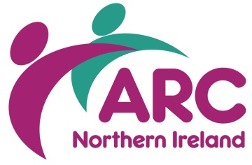

IN-HOUSE TRAINING BOOKING FORM

Name
Job Title
Organisation
Address
Town/City |  | Postcode
Email
Telephone

Course Title(s) | Numbers | Date(s)

☐ I am an ARC member ☐ I am not a member of ARC

PAYMENT

☐ I enclosed a cheque (cheques must be made out to ARC Ltd)
☐ Please invoice

All invoices will be sent to your line manager.

Name:
Address:

Please return completed booking form to:
Training Department, ARC (NI), Wildflower Way, Boucher Rd, Belfast BT12 6TA
training.ni@arcuk.org.uk

Cancellation charges will apply. For any queries or additional information please call 028 9038 0960

BOOKING ARRANGEMENTS & CANCELLATION CHARGES

Booking arrangements | ARC In-House training can only be secured by completing the appropriate booking form which is available on request from the Training Department at the ARC (NI) office.  Tel: 028 9038 0960  Email: training.ni@arcuk.org.uk / louise.hughes@arcuk.org.uk  Please Note: Booking forms are used for invoicing purposes and it is essential line management authorisation is provided, if required.
Payment | On completion of the course an invoice will be issued and payment can be made with by cheque or BACS payment.
Your cancellation charges | If the agreed date(s) become unsuitable, you must give ARC at least 3 weeks notice. You may rearrange by prior agreement with ARC alternative dates, free of cancellation fees.  If your organisation is unable to give 3 weeks notice, the cancellation charges are as follows.  Cancellation charges - training courses  10 working days before the course: 50%  5 working days before the course: 100%
ARC’s cancellation | In the case of a course cancellation by ARC, an offer of an alternative date will be provided and if this is no longer desired, a credit note or a full refund will be given.
Venue unless otherwise stated | ARC (NI)  Ash Grove  Wildflower Way  Boucher Road  BELFAST BT12 6TA  Tel: 028 9038 0960
Costs | Full Day Session  ARC Member: £650.00  Non-Member: £900.00  For a quote on bespoke training courses, contact Louise Hughes.  Booking more than one in-house course will save your organisation money as you will receive a discount on the more courses you book with us.  Louise Hughes Email: louise.hughes@arcuk.org.uk  Training Co-ordinator Tel: 028 9038 0965 / 9038 0965

