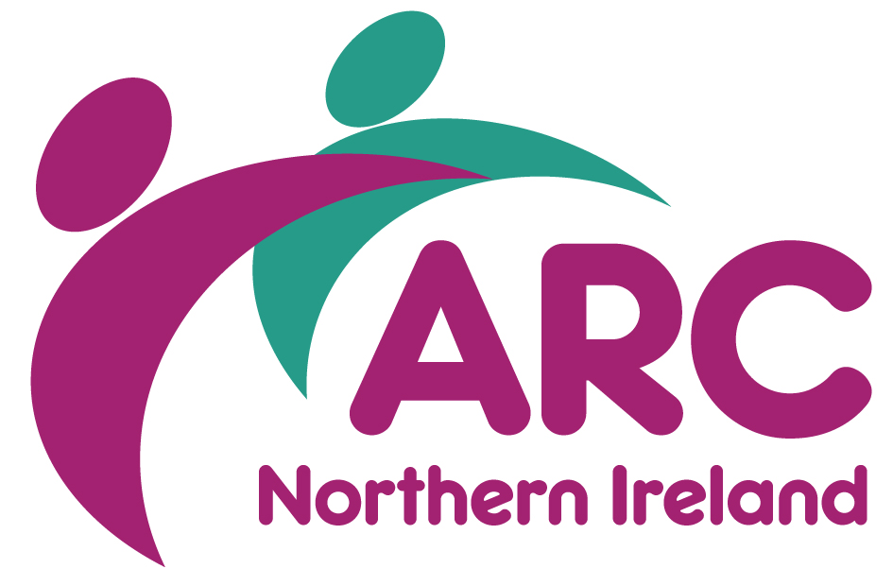
Training & Board Room Hire Costs

Members | Half Day | Full Day | Out of Hours
Board Room (10 capacity) | £30 | £50 | POA
Training Room (20 capacity) | £50 | £75 | POA

Non-Members | Half Day | Full Day | Out of Hours
Board Room (10 capacity) | £50 | £70 | POA
Training Room (20 capacity) | £75 | £100 | POA

Cost includes:
- Equipment (please identify your needs in advance)
- Free Parking
- Free WIFI

Additional Cost:
- Lunch and refreshments are available upon request.
For further information contact nimeetingroom@arcuk.org.uk or telephone 028 9038 0960

ASSOCIATION FOR REAL CHANGE (NORTHERN IRELAND)
ROOM HIRE BOOKING FORM
Name of Group
Contact Person
Address
 |  |  |  | Postcode
Telephone
Email
Date Required
Times | From |  | To |  |  | Numbers

Room Required: Training Room (maximum 25) Board Room (maximum 10)

Are you an ARC member? Yes No

EQUIPMENT
Hire of the following equipment is inclusive of Room Hire. Please indicate which is required.
Flip Chart and pens |  |  | Laptop
Multi-media Screen
 | CATERING |  | NUMBERS |  | TIME |  |  |  |  | ROOM LAYOUT
 | Tea/Coffee | £0.75 |  |  |  |  |  |  |  | Board Room  (maximum 10)
 | Tea/Coffee & Biscuits | £1.00 |  |  |  |  |  |  |  | U Shape  (maximum 12)
 | Tea/Coffee & Scones | £1.90 |  |  |  |  |  |  |  | Theatre  (maximum 25)
 | Lunch | Available on request |  |  |  |  |  |  |  | Class Room  (maximum 20)

Note:

As a representative of the above named group I have read the Term and Conditions for Room Hire and agree to be bound by them.

Signed Date

All bookings are considered provisional until the BOOKING FORM is returned to ARC (NI)

